Port Scanning with nmap:
Part-01:
Nmap ip-address

By default, Nmap sends TCP SYN requests (also called half-open scans) to scan for open ports.

Nmap -Pn ip-address
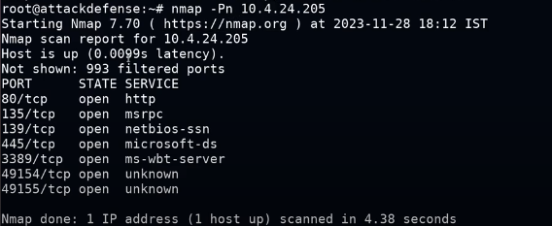

Privilege | Default Scan Type | Protocol Used | Description
Root/Admin | SYN Scan (-sS) | TCP | Sends TCP SYN packets (stealthy/fast)
Normal User | Connect Scan (-sT) | TCP | Uses full TCP handshake via OS networking

Nmap -Pn -F ip-address
It scan the commonly used 100 ports.

Nmap -Pn -p 80 ip-address

Nmap -Pn -p 80,445,3389,8080 ip-address
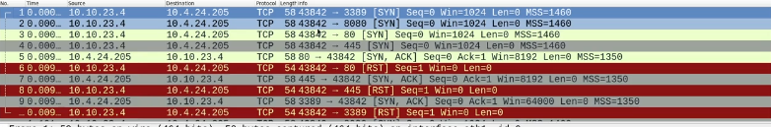
NOTE:
When you are dealing with the window system and it show the filtered then it means that the firewall is active and if it say close then it is not active.(statefull firewall)

Nmap -Pn -p1-101 ip-address

Teacher choice:
Nmap -Pn -F ip-address
Nmap -Pn -p- ip-address

Never assume anything without point.
PART:02

NOTE:
When we are performing the port scan then it check the port it sent the SYN Ping and the target replay with with SYN ACK if it is open, if it is clo0se it replays with RST and when it doesn’t replay then it means that it is filtered by firewall.

If you are not the root then to perform the SYN scan then:
Sudo Nmap -Pn -sS -F ip-address

NOTE:
Most of the system logs the tcp handshake so we use the SYN not to log the tcp handshake.
TCP connect:
Default without root.
3 wayhandshakke complete.
It is very loud./very easily detectable.
It is only used where accuracy is required and when there is no concerned for detection.

Nmap -Pn -sT ip-address

Best option is
SYN Stealth scan.

Scanning for UDP ports:
Nmap -Pn -SU ip-address
Nmap -Pn -sU53,137,138,139 ip-address

